CIFAR-10 Image Classification Project Report

1. Introduction
This project focuses on developing a Convolutional Neural Network (CNN) model to classify images from the CIFAR-10 dataset into 10 categories: airplane, automobile, bird, cat, deer, dog, frog, horse, ship, and truck. The model is built using TensorFlow/Keras and deployed as an interactive Streamlit web app for real-time predictions.

2. Model Architecture
The CNN model consists of multiple convolutional, batch normalization, activation, pooling, and dropout layers to extract hierarchical image features efficiently. Below is the architecture summary:
Layer (type) | Output Shape | Param #
Conv2D | (None, 32, 32, 32) | 896
BatchNormalization | (None, 32, 32, 32) | 128
Activation | (None, 32, 32, 32) | 0
Conv2D | (None, 32, 32, 32) | 9,248
BatchNormalization | (None, 32, 32, 32) | 128
Activation | (None, 32, 32, 32) | 0
MaxPooling2D | (None, 16, 16, 32) | 0
Dropout | (None, 16, 16, 32) | 0
Conv2D | (None, 16, 16, 64) | 18,496
BatchNormalization | (None, 16, 16, 64) | 256
Activation | (None, 16, 16, 64) | 0
Conv2D | (None, 16, 16, 64) | 36,928
BatchNormalization | (None, 16, 16, 64) | 256
Activation | (None, 16, 16, 64) | 0
MaxPooling2D | (None, 8, 8, 64) | 0
Dropout | (None, 8, 8, 64) | 0
Conv2D | (None, 8, 8, 128) | 73,856
BatchNormalization | (None, 8, 8, 128) | 512
Activation | (None, 8, 8, 128) | 0
Conv2D | (None, 8, 8, 128) | 147,584
BatchNormalization | (None, 8, 8, 128) | 512
Activation | (None, 8, 8, 128) | 0
MaxPooling2D | (None, 4, 4, 128) | 0
Dropout | (None, 4, 4, 128) | 0
Flatten | (None, 2048) | 0
Dense | (None, 256) | 524,544
BatchNormalization | (None, 256) | 1,024
Activation | (None, 256) | 0
Dropout | (None, 256) | 0
Dense | (None, 10) | 2,570
Total params: 816,938 (3.12 MB)
Trainable params: 815,530
Non-trainable params: 1,408

3. Training Performance
Below are the plots of training and validation performance metrics:
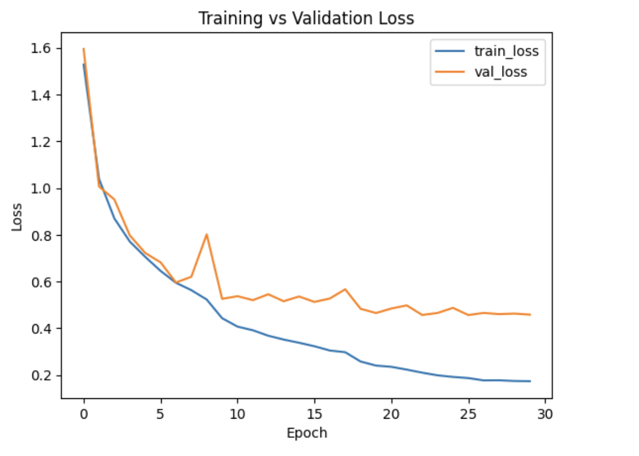
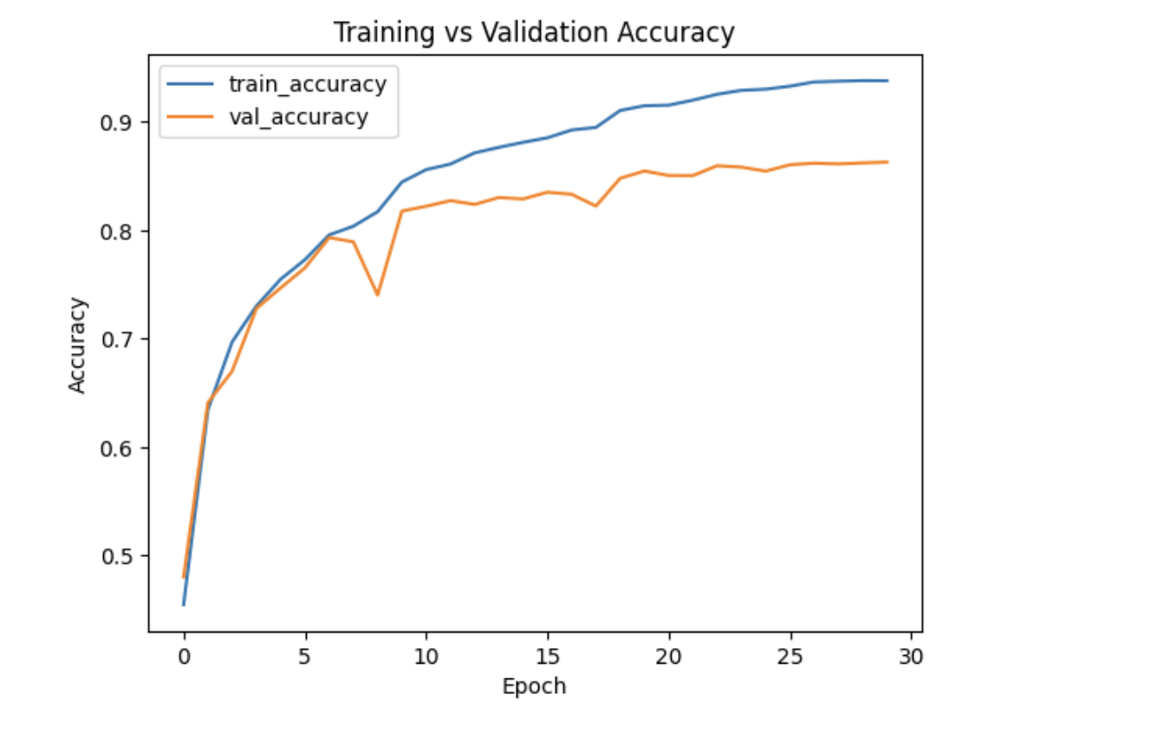
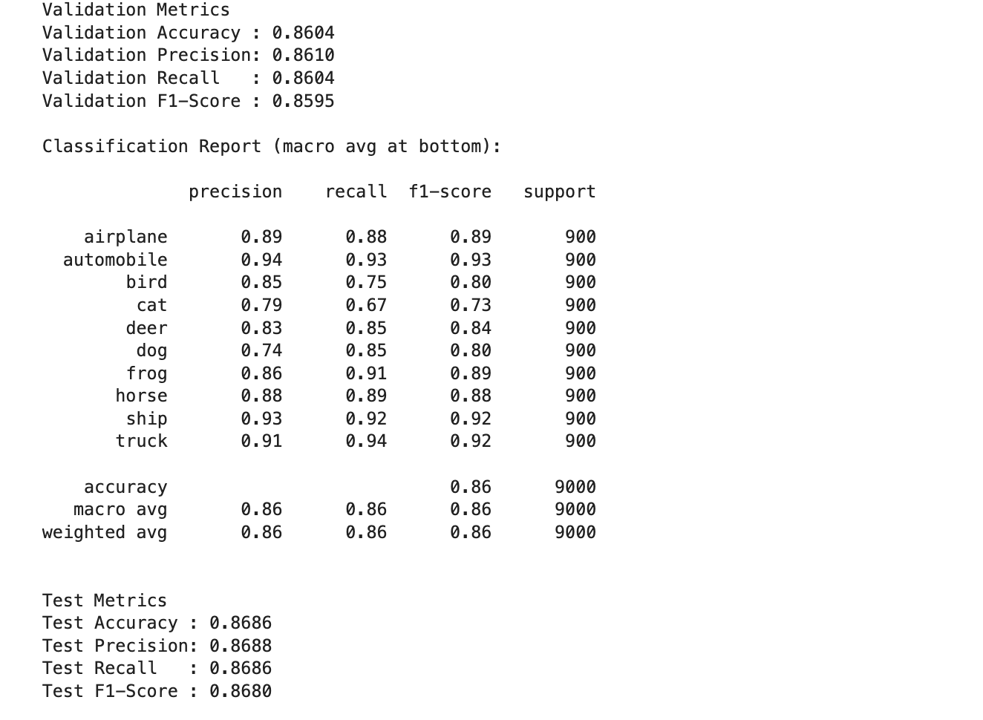
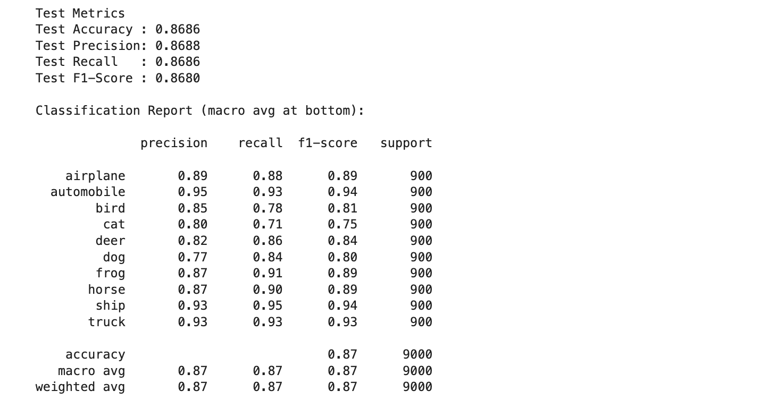
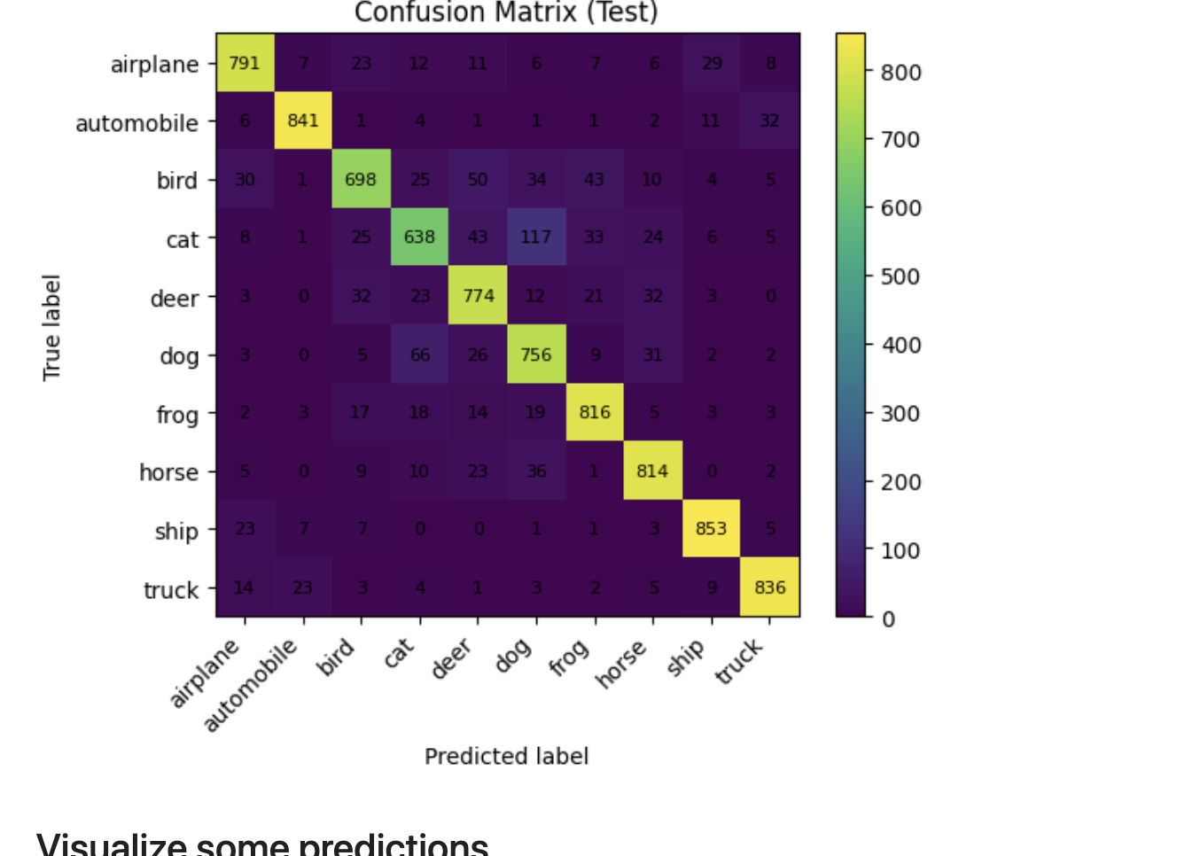

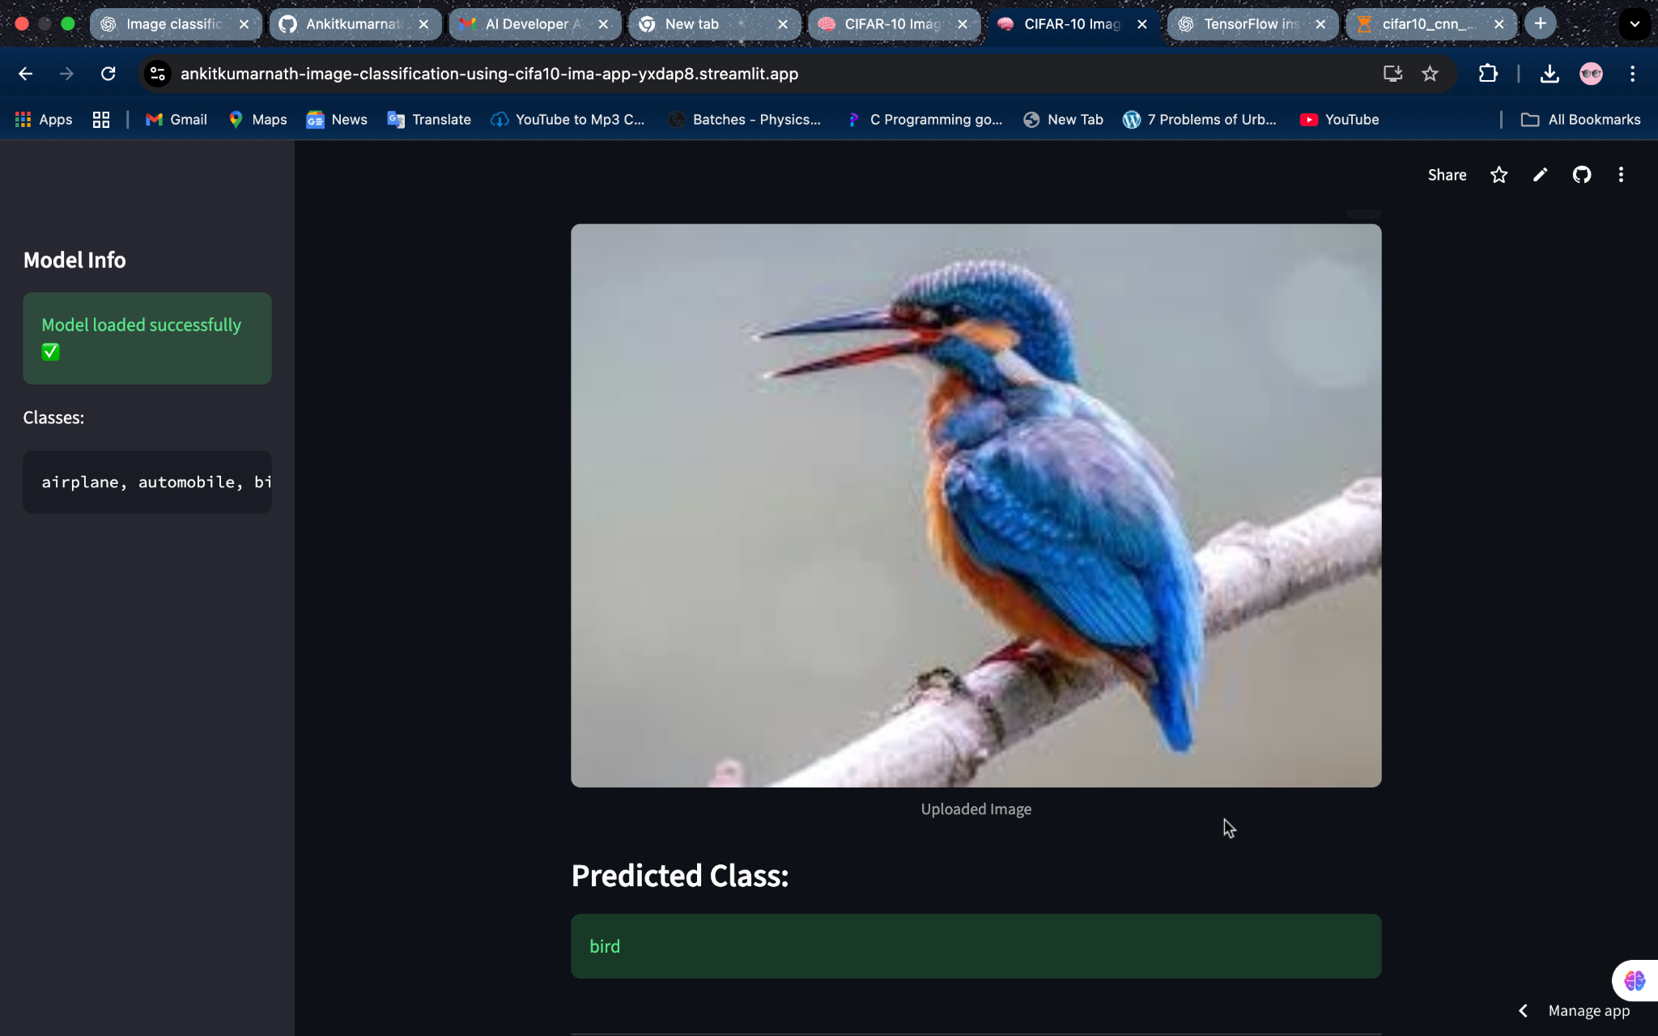
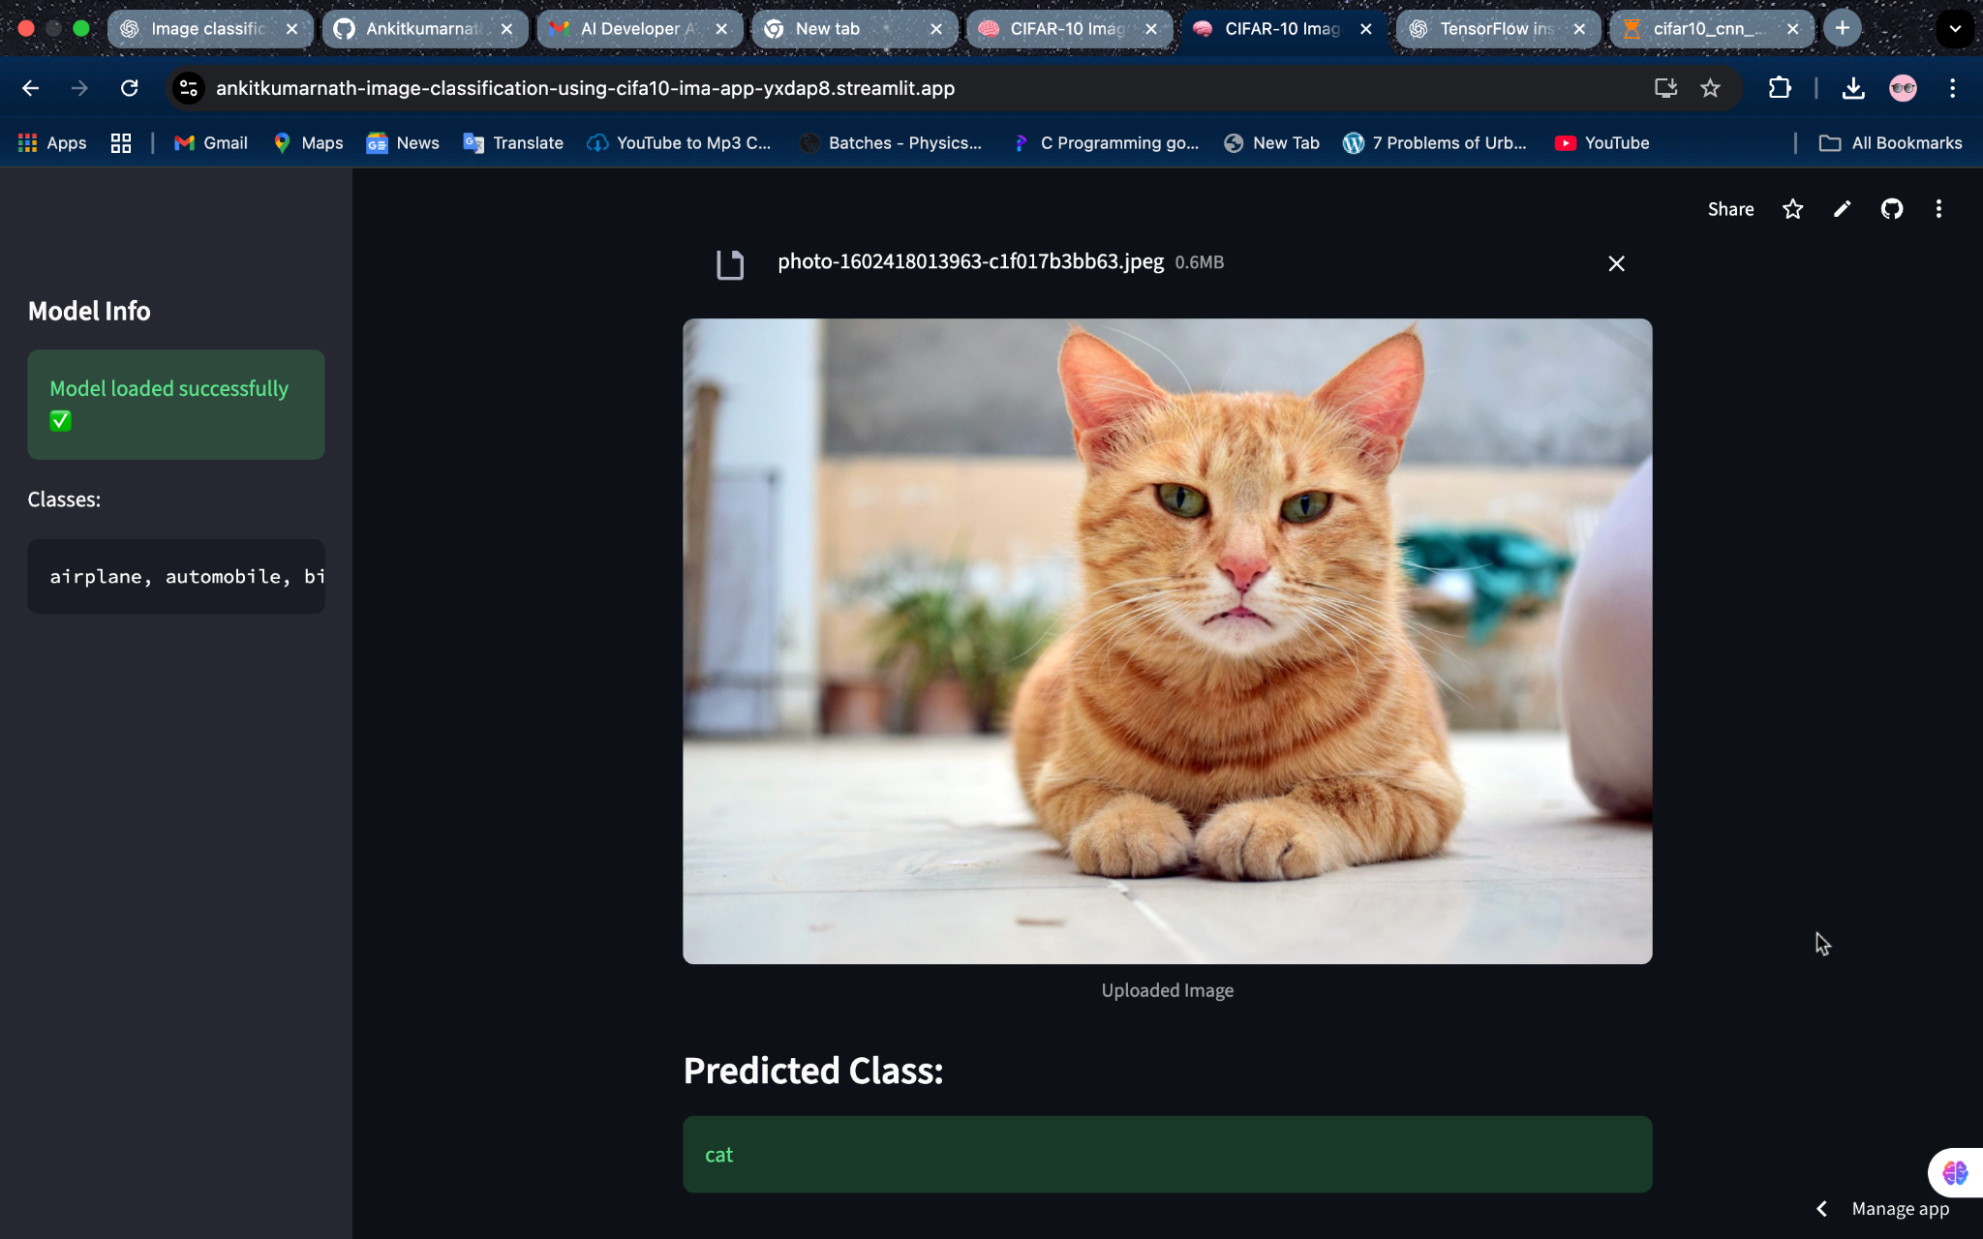

4. Conclusion
The CIFAR-10 CNN model achieved a test accuracy of approximately 86.8%, demonstrating strong performance across most categories. The model effectively distinguishes between different object classes and performs well on unseen data. Deployment through Streamlit provides an interactive and accessible interface for real-time image classification.
git hub link: https://github.com/Ankitkumarnath/image_classification_using_cifa10-images/tree/main
app link: https://ankitkumarnath-image-classification-using-cifa10-ima-app-yxdap8.streamlit.app/

